**Sprint 1 Plan: Spotify X Apple Music Blend, 4/23/24, Revision 1 (4/26/24)**

∙ **Goal:** For the first sprint we want to get our tools set up as well as acquire and access the Spotify and Apple Music dev APIs. We also want to test the API tools to make sure they work.

User story 1: As a Spotify or Apple Music user, I want to be able to log in to my music streaming platform so that the blended playlist can accurately reflect my music taste.

*Task 1: Set up a MERN stack (2 hrs)*

*Task 2: Get Spotify API dev tools (1 hr)*

*Task 3: Ensure Spotify calls can be made and received (2 hr)*

*Task 4: Ensure Spotify authentication works (1 hr)*

*Task 5: Get Apple Music dev tools (1 hr)*

*Task 6: Ensure Apple Music calls can be made and received (2 hr)*

*Task 7: Ensure Apple Music authentication works (1 hr)*

*Total for user story 1: 10 hours*

∙ **Team roles:**

*Neha: Project Owner, Sprint 1 Scrum Master*

*Kaustubh: Developer*

*Bode: Developer*

*Justin: Developer*

*Chris: Developer*

*Shayan: Developer*

∙ **Initial task assignment:**

*Team member 1: user story, initial task*

*Neha: User story 1, Task 2, Task 5*

*Kaustubh: User story 1, Task 1, Task 6*

*Bode: User story 1, Task 1, Task 5*

*Justin: User story 1, Task 3, Task 4*

*Chris: User story 1, Task 1, Task 2*

*Shayan: User story 1, Task 7 (Not here at start)*

∙ **Initial burnup chart:**

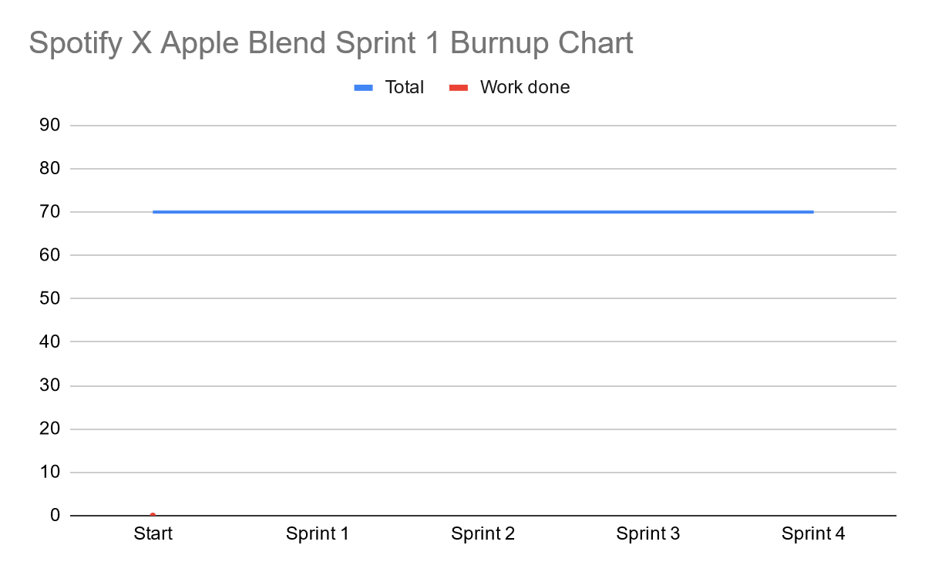

∙ **Initial scrum board:**

| **User Stories** | **Tasks Not Started** | **Tasks in Progress** | **Tasks Completed** |
| --- | --- | --- | --- |
| As a Spotify or Apple Music user, I want to be able to log in with my Spotify/Apple Music account so that the site can access the music I listen to. | * *Task 7: Ensure Apple Music authentication works (1 hr)* | * *Task 6: Ensure Apple Music calls can be made and received (2 hr)* | * Task 1: Set up a MERN stack * Task 2: Get Spotify API dev tools * Task 3: Ensure Spotify calls can be made and received * Task 4: Ensure Spotify authentication works |

∙ **Scrum times:**

* Thursday 6:00 - 7:00 PM TA/tutor meeting
* Saturday 1:00-2:00 PM
* Wednesday 2:00-3:00 PM